# 1. Pre-requisites needed for Device to Cloud Labs

In order to be able to complete the Blinky and the Cloud lab you will need to make sure your machine has the following pre-requisites.

**1.1 Setup your device**

1. **Make sure you are running the public release of Windows 10 (version 10240) or better**. You can upgrade from [here](http://www.microsoft.com/en-us/software-download/windows10). If you are already running Windows 10, you can find your current build number by clicking the start button and typing “winver” and hitting enter.
2. **Install Visual Studio Community 2015** [here](http://go.microsoft.com/fwlink/?LinkID=534599). Visual Studio Professional 2015 and Visual Studio Enterprise 2015 can be downloaded from [here](https://www.visualstudio.com/vs-2015-product-editions).

**NOTE:** If you choose to install a different edition of VS 2015, make sure to do a **Custom** install and select the checkbox **Universal Windows App Development Tools** -> **Tools and Windows SDK**

1. **Validate your Visual Studio installation** by selecting Help > About Microsoft Visual Studio. The required version of **Visual Studio** is 14.0.23107.0 D14Rel. The required version of **Visual Studio Tools for Universal Windows Apps** is 14.0.23121.00 D14OOB.
2. **Install Windows IoT Core Project Templates** from [here](https://visualstudiogallery.msdn.microsoft.com/06507e74-41cf-47b2-b7fe-8a2624202d36). Alternatively, the templates can be found by searching for Windows IoT Core Project Templates in the [Visual Studio Gallery](https://visualstudiogallery.msdn.microsoft.com/) or directly from Visual Studio in the Extension and Updates dialog (Tools > Extensions and Updates > Online).
3. Make sure you’ve **enabled developer mode** by following [these instructions](https://msdn.microsoft.com/library/windows/apps/xaml/dn706236.aspx).
   1. **Download IoT Watcher**

Install the Windows 10 IoT Core tools

1. [Download](http://go.microsoft.com/fwlink/?LinkId=616847) the ISO for the Raspberry Pi 2 from the Microsoft Download Center.
2. **Save the ISO** to a local folder

http://ms-iot.github.io/content/images/SetupRPI/Iso.PNG

1. Double click on the ISO (IoT Core RPi.iso). It will automatically mount itself as a virtual drive so you can access the contents.

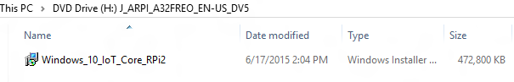

1. Install **Windows_10_IoT_Core_RPi2.msi**. When installation is complete, flash.ffu will be located at **C:\Program Files (x86)\Microsoft IoT\FFU\RaspberryPi2**

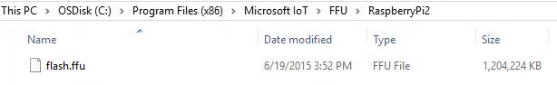

1. Eject the Virtual CD when done
   1. **Find you Device**

<<add explanation around the PI numbering and screenshot IoT core>>